CSCI 5408 – Data Management, Warehousing and Analytics Assignment 1

Problem 2 Report: Nova Scotia Parks

I visited https://parks.novascotia.ca/ for identifying key entities and attributes.

|  |  |
| --- | --- |
| **Entity** | **Reason of Selection** |
| Park | This is the strong entity representing park details as attributes on  which other weak entities will depend |
| Visitor | This is the strong entity refers to the people who visit the park. |
| Event | Different events are organized in park which is weak entity. |
| Reservation | Reservations can be made for different events which is strong  entity. |
| Amenities | Event organized in park provides many amenities for the events  and it is a strong entity. |
| Accommodation | In parks there are camp sites and hotels where people can stay. |
| Rules | Every park has rules and regulations to maintain it |
| Division | Every park has many divisions |
| Employee | To maintain park, it should have employees |
| Facilities | Park has facilities for the visitors |
| Invoice | Employees generate bills for various events, food, booking,  accommodation, and many more |
| Image | Each park has images |

There are total 13 entities which I discovered and the attributes of all those entities are mentioned below:

# Park

* + park_id
  + name
  + location
  + address
  + timing
  + altitude
  + url
  + description
  + area_covered

# Visitor

* + visitor_id
  + name
  + dob
  + age
  + contact
  + gender
  + email
  + address

# Event

* + event_id
  + name
  + organizer
  + description
  + location
  + time
  + date

# Reservation

* + reservation_id
  + name
  + date

# Amenities

* + amenities_id
  + name

# Accomodation

* + acc_id
  + name
  + location
  + description
  + rating
  + web_url

# Rules

* + rule_id
  + description
  + issue_date

# Division

* + div_id
  + div_name
  + div_description
  + contact

# Employee

* + employee_id
  + name
  + email
  + address
  + joining_date
  + dob
  + age
  + gender
  + salary

# Facilities

* + facility_id
  + name
  + description

# Invoice

* + invoice_id
  + invoice_type
  + invoice_date

# Image

* + image_id
  + name
  + source_url
  + height
  + width

After finding valid strong and weak entities, I defined attributes and then I drew the initial ER diagram for conceptual phase where I defined all the relationships among the entities. The initial Chen model diagram is attached below:

ERD_Initial_P2

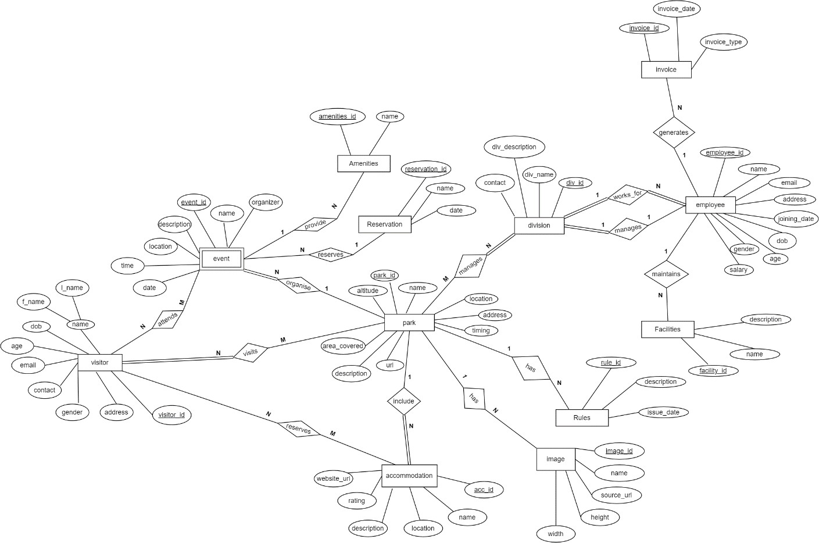

After creating initial Chen model, I found some new attributes in the form of composite attributes. So, I splitted the eligible attributes to composite attributes where I represented name in the form of composite attributes f_name and l_name. Address as street, city, province, zipcode and country. Location as latitude and longitude.

Then, I identified multivalued attributes (such as contact for division entity)

I also identified derived attributes in the form of attribute age where age can be determined from dob.

Along with solving the fan trap design issue, I improved the cardinality in the new model. The final ER diagram is attached below:

ERD_Final_P2

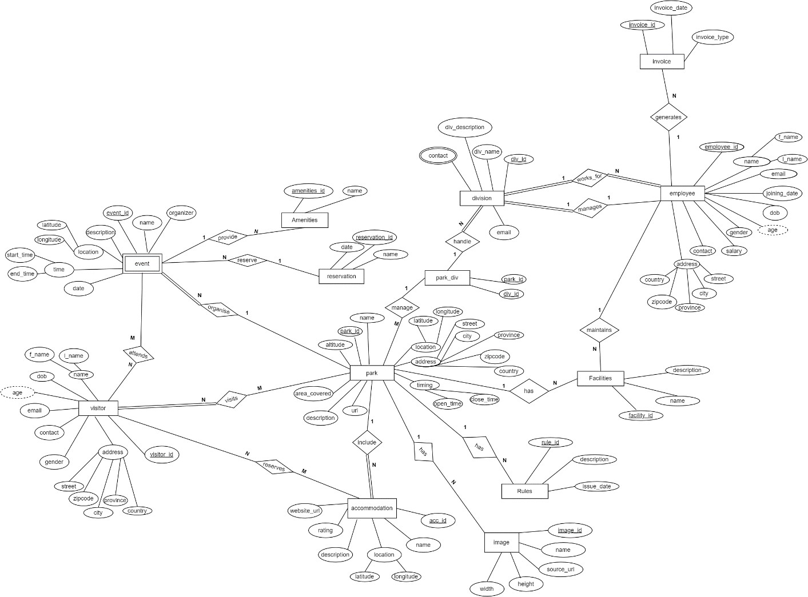

References:

[1] draw.io [online] : <https://app.diagrams.net/>

[2] Nova Scotia Parks [online] : <https://parks.novascotia.ca/>

[3] Chen-model notations [online] : <https://vertabelo.com/blog/chen-erd-notation/>

“I Sagarkumar .P. Vaghasia, declare that in assignment 1 of CSCI 5408 course, data scrapping is not done programmatically or using any online or offline tools. However, the webpages or the domain mentioned in this document are visited manually, and some useful information is gathered for education purpose only. Information, such as email, personal contact numbers, or names of people are not extracted. The course instructor or the Faculty of Computer Science cannot be held responsible for any misuse of the extracted data”.